SIMATS ENGINEERING
SAVEETHA INSTITUTE OF MEDICAL AND TECHNICAL SCIENCES
CHENNAI – 602105
Department of Computer Science and Engineering

ASSESSMENT TOOL 2 – SCHEMA ANALYSIS AND VIVA VOCE

Course Code: | DSA05 | Course Title: | Query Processing for Data Science With Real Time Applications
CO Assessed: | CO2 | Assessment: | Tool 2 – Schema Analysis and Viva Voce
Weightage: |  | Total Marks: | 35 Marks
CO2 Statement: Use Python basics and SQL libraries to connect to databases SQLite, MySQL, PostgreSQL and perform CRUD operations like Create, Read, Update, Delete. (BL6)
Student Name: | P. SIDDARDHA | Reg. No.: | 192424271
Section / Batch: | AIDS/2024 | Date of Submission:
Faculty In-charge: | Dr. B. Shyamala Gowri | Project Mode: | Individual Submission

Code of Conduct
I ___P. SIDDARDHA (192424271)___ (Name / Reg No) certify that this submission is my original work and that I have adhered to all guidelines specified for this assessment. I understand that any violation of academic integrity rules will result in disciplinary action.
Signature: ___P. SIDDARDHA___

Identification of Entities and Attributes (5 Marks) | Understanding of Relationships (5 Marks) | Analysis of Keys and Constraints (5 Marks) | Detection of Design Issues (10 Marks) | Viva Voce (5 Marks) | Total (35 Marks)
2. Hospital Management System (SQLite3)

A hospital database contains:
- Patient(PatientID, Name, Age)
- Doctor(DoctorID, DoctorName, Specialization)
- Appointment(AppointmentID, PatientID, DoctorID, Date)
- Prescription(PrescriptionID, AppointmentID, Medicine)
Multiple patients can consult the same doctor.

Code:
import sqlite3

try:

# Connect to SQLite Database
conn = sqlite3.connect("hospital_db.db")
cursor = conn.cursor()

print("Connected to SQLite Successfully")

# Enable Foreign Key Support
cursor.execute("PRAGMA foreign_keys = ON")

# Drop tables (Child tables first)
cursor.execute("DROP TABLE IF EXISTS Payment")
cursor.execute("DROP TABLE IF EXISTS Treatment")
cursor.execute("DROP TABLE IF EXISTS Appointment")
cursor.execute("DROP TABLE IF EXISTS Doctor")
cursor.execute("DROP TABLE IF EXISTS Patient")

# Create Patient Table
cursor.execute("""
CREATE TABLE Patient(
PatientID INTEGER PRIMARY KEY,
PatientName TEXT,
Age INTEGER,
Gender TEXT,
Disease TEXT
)
""")

# Create Doctor Table
cursor.execute("""
CREATE TABLE Doctor(
DoctorID INTEGER PRIMARY KEY,
DoctorName TEXT,
Specialization TEXT
)
""")

# Create Appointment Table
cursor.execute("""
CREATE TABLE Appointment(
AppointmentID INTEGER PRIMARY KEY,
PatientID INTEGER,
DoctorID INTEGER,
AppointmentDate TEXT,
FOREIGN KEY (PatientID)
REFERENCES Patient(PatientID)
ON DELETE CASCADE,
FOREIGN KEY (DoctorID)
REFERENCES Doctor(DoctorID)
ON DELETE CASCADE
)
""")

# Create Treatment Table
cursor.execute("""
CREATE TABLE Treatment(
TreatmentID INTEGER PRIMARY KEY,
PatientID INTEGER,
Prescription TEXT,
LabTest TEXT,
FOREIGN KEY (PatientID)
REFERENCES Patient(PatientID)
ON DELETE CASCADE
)
""")

# Create Payment Table
cursor.execute("""
CREATE TABLE Payment(
PaymentID INTEGER PRIMARY KEY,
PatientID INTEGER,
Amount REAL,
PaymentStatus TEXT,
FOREIGN KEY (PatientID)
REFERENCES Patient(PatientID)
ON DELETE CASCADE
)
""")

conn.commit()

# Insert Patient Records
cursor.execute("INSERT INTO Patient VALUES (101,'Ramesh',45,'Male','Fever')")
cursor.execute("INSERT INTO Patient VALUES (102,'Priya',30,'Female','Diabetes')")

# Insert Doctor Records
cursor.execute("INSERT INTO Doctor VALUES (201,'Dr.Kumar','General')")
cursor.execute("INSERT INTO Doctor VALUES (202,'Dr.Anita','Diabetologist')")

# Insert Appointment Records
cursor.execute("INSERT INTO Appointment VALUES (1,101,201,'2026-07-14')")
cursor.execute("INSERT INTO Appointment VALUES (2,102,202,'2026-07-15')")

# Insert Treatment Records
cursor.execute("INSERT INTO Treatment VALUES (1,101,'Paracetamol','Blood Test')")
cursor.execute("INSERT INTO Treatment VALUES (2,102,'Insulin','Sugar Test')")

# Insert Payment Records
cursor.execute("INSERT INTO Payment VALUES (1,101,500.00,'Paid')")
cursor.execute("INSERT INTO Payment VALUES (2,102,1200.00,'Pending')")

conn.commit()

print("\nPatient Records")

cursor.execute("SELECT * FROM Patient")

for row in cursor.fetchall():
print(row)

# Update Record
cursor.execute("""
UPDATE Patient
SET Disease='Viral Fever'
WHERE PatientID=101
""")

conn.commit()

print("\nAfter Update")

cursor.execute("SELECT * FROM Patient")

for row in cursor.fetchall():
print(row)

# Search Record
print("\nSearch Result")

cursor.execute("""
SELECT * FROM Patient
WHERE Disease='Viral Fever'
""")

for row in cursor.fetchall():
print(row)

# Delete Record
cursor.execute("DELETE FROM Patient WHERE PatientID=102")

conn.commit()

print("\nAfter Delete")

cursor.execute("SELECT * FROM Patient")

for row in cursor.fetchall():
print(row)

except sqlite3.Error as e:

print("Error:", e)

finally:

conn.close()

print("\nSQLite Connection Closed")

Output:
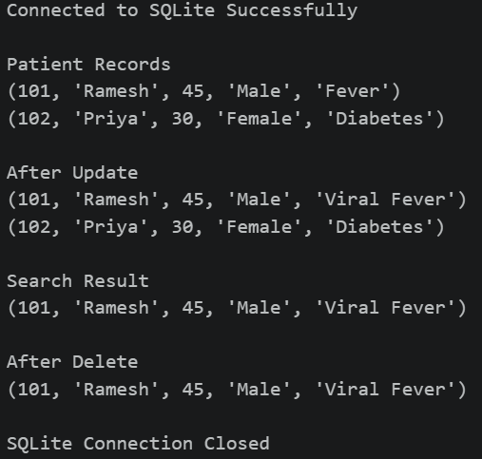

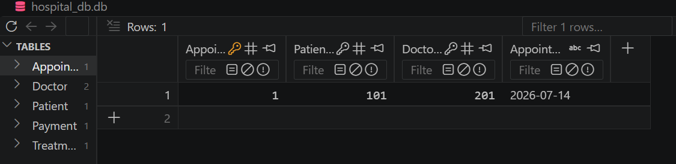

Viva Questions
Q1. What problems might occur if prescription details are stored directly in the Appointment table?
A. Storing prescription details in the Appointment table causes data redundancy and update, insertion, and deletion anomalies. It also makes it difficult to store multiple medicines for a single appointment.

Q2. How would the schema change if a prescription contains multiple medicines?
A. Create a separate table, such as PrescriptionMedicine(PrescriptionID, Medicine), linked to the Prescription table. This allows one prescription to store multiple medicines and keeps the database normalized.

6. Employee Payroll System

A company database contains:
- Employee(EmployeeID, Name, DepartmentID)
- Department(DepartmentID, DepartmentName)
- Payroll(PayrollID, EmployeeID, Salary, Month)
Employees belong to departments and receive monthly salaries.

Code:
import mysql.connector
from mysql.connector import Error

try:

# Connect to MySQL
conn = mysql.connector.connect(
host="127.0.0.1",
user="root",
password="",
database="employee_db",
port=3306
)

if conn.is_connected():
print("Connected to MySQL Successfully")

cursor = conn.cursor()

# Drop tables (Child table first)
cursor.execute("DROP TABLE IF EXISTS Payroll")
cursor.execute("DROP TABLE IF EXISTS Employee")
cursor.execute("DROP TABLE IF EXISTS Department")

# Create Department Table
cursor.execute("""
CREATE TABLE Department(
DepartmentID INT PRIMARY KEY,
DepartmentName VARCHAR(50)
)
""")

# Create Employee Table
cursor.execute("""
CREATE TABLE Employee(
EmployeeID INT PRIMARY KEY,
Name VARCHAR(50),
DepartmentID INT,
FOREIGN KEY (DepartmentID)
REFERENCES Department(DepartmentID)
ON DELETE CASCADE
)
""")

# Create Payroll Table
cursor.execute("""
CREATE TABLE Payroll(
PayrollID INT PRIMARY KEY,
EmployeeID INT,
Salary DECIMAL(10,2),
Month VARCHAR(20),
FOREIGN KEY (EmployeeID)
REFERENCES Employee(EmployeeID)
ON DELETE CASCADE
)
""")

conn.commit()

# Insert Department Records
cursor.execute("INSERT INTO Department VALUES (1,'HR')")
cursor.execute("INSERT INTO Department VALUES (2,'IT')")

# Insert Employee Records
cursor.execute("INSERT INTO Employee VALUES (101,'Ramesh',1)")
cursor.execute("INSERT INTO Employee VALUES (102,'Priya',2)")

# Insert Payroll Records
cursor.execute("INSERT INTO Payroll VALUES (1,101,35000.00,'July')")
cursor.execute("INSERT INTO Payroll VALUES (2,102,50000.00,'July')")

conn.commit()

print("\nEmployee Records")

cursor.execute("SELECT * FROM Employee")

for row in cursor.fetchall():
print(row)

# Update Record
cursor.execute("""
UPDATE Payroll
SET Salary=55000.00
WHERE EmployeeID=102
""")

conn.commit()

print("\nAfter Update")

cursor.execute("SELECT * FROM Payroll")

for row in cursor.fetchall():
print(row)

# Search Record
print("\nSearch Result")

cursor.execute("""
SELECT * FROM Payroll
WHERE Salary=55000.00
""")

for row in cursor.fetchall():
print(row)

# Delete Record
cursor.execute("DELETE FROM Employee WHERE EmployeeID=101")

conn.commit()

print("\nAfter Delete")

cursor.execute("SELECT * FROM Employee")

for row in cursor.fetchall():
print(row)

except Error as e:

print("Error:", e)

finally:

if 'conn' in locals() and conn.is_connected():
cursor.close()
conn.close()
print("\nMySQL Connection Closed")

Output:
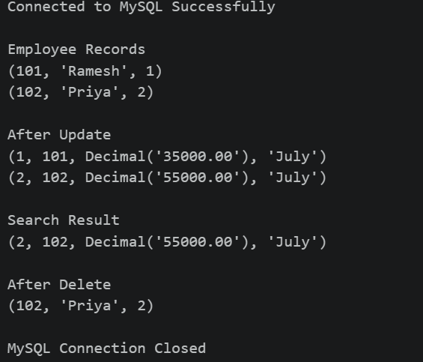

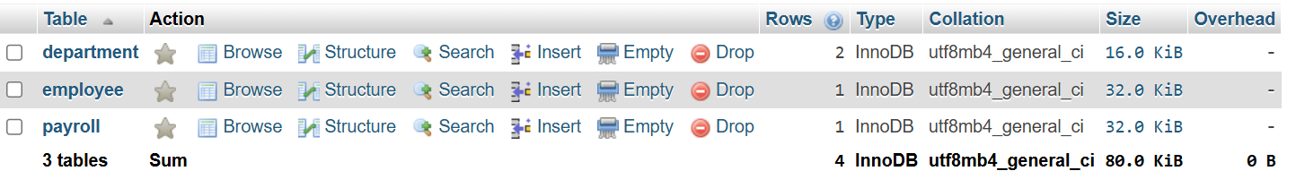

Viva Questions
Q1. Why is Department information separated into a different table?
A. Storing department information in a separate table avoids data redundancy, maintains data consistency, and follows database normalization. Multiple employees can belong to the same department by referring to the DepartmentID.

Q2. What redundancy issues would arise if department details were stored in Employee records?
A. Storing department details directly in the Employee table would repeat the same department information for many employees. This causes data redundancy, wastes storage space, and leads to update, insertion, and deletion anomalies. Keeping department details in a separate table maintains a normalized database.

